Unit 2: Early Humans
Permanent: #5

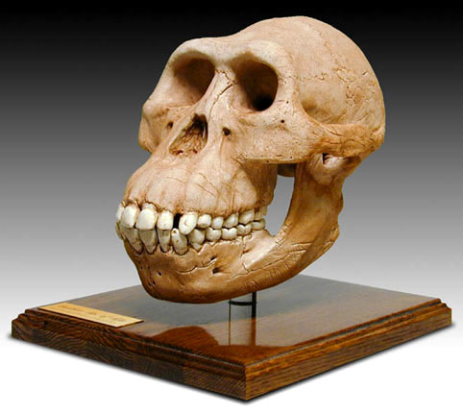
Reading Standards:
1. Make inferences from evidence
2. Determine Main Idea/ Summary (Cornell Notes)
3. Distinguish between Fact / Opinion / Reasoned Judgment
4. Determine if a source is credible

*Charles Darwin-
- *Evolution-

- *Natural Selection-

Anthropologist/Paleoanthropologist-

Hominids-
- Lucy- Australopithecus afarensis-
  - Biped-

- Homo habilis-
  - *Tools-

- Homo erectus-
  - *Fire-
1.
2.
3.
4.
  - Migrate-

- Homo sapiens neanderthalensis-

- Homo sapiens sapiens-

- *Ice Age-

*Otzi-

*Credible-
- Author’s relationship to text (no definition required)

- Location (no definition required)

- Mostly facts and reasoned judgment (no definition required)

*Fact-

*Opinion-

*Reasoned Judgment-

From Hunters and Gatherers to Farmers
Paleolithic Age-

Neolithic Age-

Fertile Crescent-

Domesticate-

Agriculture-

Nomads-

Trade-

*means not in textbook

